ORCV Full SSSC course
Emergencies (Causes) exercises work sheet
The adventures of “Lucky Phil”

Instructions
Save and edit this document electronically. Alternatively print it and use a pen to answer the questions. Work through the scenarios, which we will also cover in the online course. Answer the questions in this document as you do so.

Bring your responses to the practical day and be ready to discuss them with the class.

Meet “Lucky Phil”
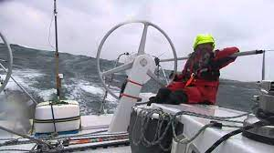

Phil loves sailing offshore. He has raced, delivered and cruised for the last twenty-five years, always on other people’s boats. He is known by his mates as “Lucky Phil”. Whenever something goes wrong, Phil always seems to be on board. He insists it is just a coincidence.

Let’s look at some of his adventures. What do you think ? Would you sail with Phil ?

Scenario 1 – Man overboard
Phil was on watch, steering offshore while several of his crew members were on the bow doing a sail change. It was very dark and windy so he could not see what they are doing. Phil heard someone shout “man overboard” and just managed to spot a crew member in the water as he sailed past.
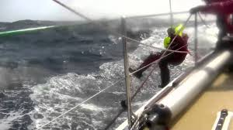
Question | Your answer
Q1 What might have caused this?
Q2 Could it have been avoided? If so, how?
Q3 What should already be in place to help deal with this?
Q4 What still needs to be done to deal with this?
Q5 Any other comments or observations ?

Scenario 2 – Steering loss
Phil was on watch steering offshore, running downwind under spinnaker when all of a sudden there was a bang and the helm started feeling strange and unresponsive. The yacht rounded up and heeled dramatically with the spinnaker in the water. Phil looked up to see the crew desperately trying to hang on while one shouted that they could see the rudder floating away.
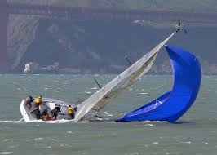
Question | Your answer
Q1 What might have caused this?
Q2 Could it have been avoided? If so, how?
Q3 What should already be in place to help deal with this?
Q4 What still needs to be done to deal with this?
Q5 Any other comments or observations ?

Scenario 3 – Knocked down by a wave
Phil was on watch, steering through a storm with a heavily reefed main and storm jib. He was sailing on a cracked sheet reach, picking his way across the waves. All of a sudden, Phil heard a dull roar and was hit broadside by a large, unexpected wave. He hung on tight as the yacht rolled, it continued beyond 90 degrees so had to hold his breath as he was flung into the water.
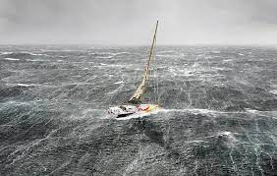
Question | Your answer
Q1 What might have caused this?
Q2 Could it have been avoided? If so, how?
Q3 What should already be in place to help deal with this?
Q4 What still needs to be done to deal with this?
Q5 Any other comments or observations ?

Scenario 4 – Mast loss
Phil was sailing along, helming offshore on a delivery in a moderate breeze, when all of a sudden he heard a loud cracking noise and looked up to see the top half of the mast fold over on itself and drop to the deck along with what was left of the sails. There was a tangle of ropes and the spreaders were banging on the side of the yacht as waves hit it. He was pleased to find the crew on deck were all okay, he wasn’t sure about the ones downstairs. Night was coming and there was nobody else nearby that he knew of.
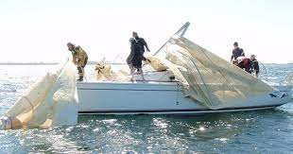
Question | Your answer
Q1 What might have caused this?
Q2 Could it have been avoided? If so, how?
Q3 What should already be in place to help deal with this?
Q4 What still needs to be done to deal with this?
Q5 Any other comments or observations ?

Scenario 5 – Keel loss
Phil was sailing along, helming offshore on a delivery in a building breeze, when all of a sudden he heard a groan followed by a crunching noise. He felt the yacht heel over and continue to roll. Before long he found himself in the water, still tethered to the rear of the yacht looking at the upturned hull, which was clearly missing its keel. The rest of the crew were downstairs, he was the only one on deck at the time.
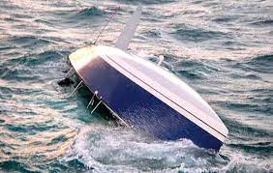
Question | Your answer
Q1 What might have caused this?
Q2 Could it have been avoided? If so, how?
Q3 What should already be in place to help deal with this?
Q4 What still needs to be done to deal with this?
Q5 Any other comments or observations ?

Scenario 6 – Engine loss
Phil was on a long delivery from New Zealand back to Australia and it was approaching the fourth night at sea. He noticed the voltage had dropped and decided it was time to run the engine to charge the batteries. No matter what they tried, the engine will not crank over and start. None of the crew on board were sure what to do next. Nobody on board was overly mechanically minded.
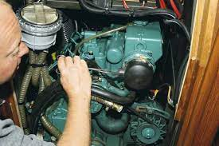
Question | Your answer
Q1 What might have caused this?
Q2 Could it have been avoided? If so, how?
Q3 What should already be in place to help deal with this?
Q4 What still needs to be done to deal with this?
Q5 Any other comments or observations ?

Scenario 7 – Flooding
Phil was fast asleep during a yacht delivery when he flung his arm out of his bunk and felt water. Curious, he looked over the edge of his bunk and was dismayed to find over a foot of water sloshing around inside the boat. Everyone else was on deck, they obviously hadn’t noticed it yet.
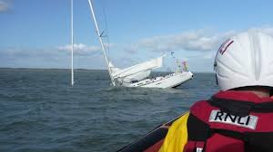
Question | Your answer
Q1 What might have caused this?
Q2 Could it have been avoided? If so, how?
Q3 What should already be in place to help deal with this?
Q4 What still needs to be done to deal with this?
Q5 Any other comments or observations ?

Scenario 8 – Run aground
Phil was downstairs cooking dinner during a delivery down the East Coast of Australia. Suddenly he was thrown forward as the boat hit something. There were shouts from on deck and he felt the boat had stopped moving. One look at the chart plotter, after zooming in, showed they were on a reef.
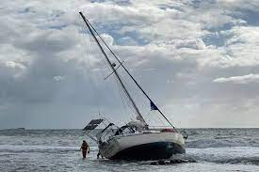
Question | Your answer
Q1 What might have caused this?
Q2 Could it have been avoided? If so, how?
Q3 What should already be in place to help deal with this?
Q4 What still needs to be done to deal with this?
Q5 Any other comments or observations ?

Scenario 9 – Collision
Phil was awoken in middle of the night by a sickening crunch and shouting. He was competing in an offshore race and they were doing quite well. There were shouts from on deck, and several other bangs as the yacht lurched to one side. After poking his head up through the hatch, it was clear the yacht had collided with another competitor.
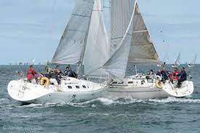
Question | Your answer
Q1 What might have caused this?
Q2 Could it have been avoided? If so, how?
Q3 What should already be in place to help deal with this?
Q4 What still needs to be done to deal with this?
Q5 Any other comments or observations ?

Scenario 10 – Fire
Phil was cruising around Tasmania with a couple of friends. He was downstairs making a cup of tea on the gas stove while the other crew were on deck refilling the dinghy’s outboard motor. They needed it for the night anchorage they had planned. He heard shouts after one of the crew dropped the jerry, spilling petrol into the rear lazarette storage locker. Phil could smell petrol fumes from where he was. Suddenly, as the crew were busy berating each other over the spill, he heard a woosh as the fumes ignited and flames appeared from the lazarette.
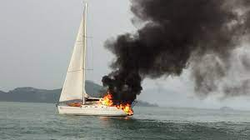
Question | Your answer
Q1 What might have caused this?
Q2 Could it have been avoided? If so, how?
Q3 What should already be in place to help deal with this?
Q4 What still needs to be done to deal with this?
Q5 Any other comments or observations ?

Scenario 11 – Medical incident
Phil was sailing along during a delivery to Adelaide. It was a lovely day, so all the crew were on deck chatting. Suddenly, one of the crew, who was standing at the time, staggered, groaning and holding his head, then collapsed onto the deck. Several of you had done first aid training so laid the crew member down in a recovery position and checked for breathing. The crew member appeared to be breathing effectively and you felt a strong pulse. The crew member appeared to be unconscious. The yacht was quite a few hours from any harbor, well offshore to avoid cray pots.
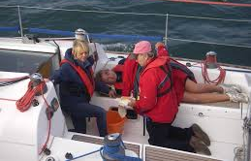
Question | Your answer
Q1 What might have caused this?
Q2 Could it have been avoided? If so, how?
Q3 What should already be in place to help deal with this?
Q4 What still needs to be done to deal with this?
Q5 Any other comments or observations ?

